Pokhara University

Level: Bachelor | Semester – Spring | Year : 2009
Programme: BE |  | Full Marks : 100
 |  | Pass Mark : 45
Course: Applied Mechanics (Dynamics) |  | Time : 3 hrs

Candidates are required to give their answers in their own words as far as practicable.
The figures in the margin indicate full marks.

Attempt all the questions.

1. | - The position of a particle which moves along a straight line is defined by the relation x = t³ -6t² -15t+40, where x is expressed in meters and t is in seconds. Determine (a) the time at which the velocity will be zero. (b) the acceleration of the particle at that time (c) the distance travelled by the particle form t = 4s to 6s.  - A stone is thrown from the top of a building upward at an angle of 40⁰ to the horizontal with an initial velocity of 30m/sec shown in fig. neglecting air resistance determine (a) the horizontal distance form the point of projection to the point where the stone strikes the ground (b) the greatest elevation reached by the projectile above the ground. (c) time of flight.  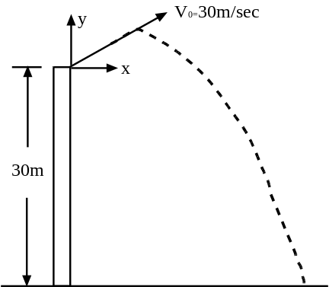 | 7  8
2. | The two blocks shown start from rest. The pulley are frictionless and the pulley is assumed to be negligible mass. Determine the acceleration of each block and the tension in each cord. Take µ  coefficient of friction is 0.2.  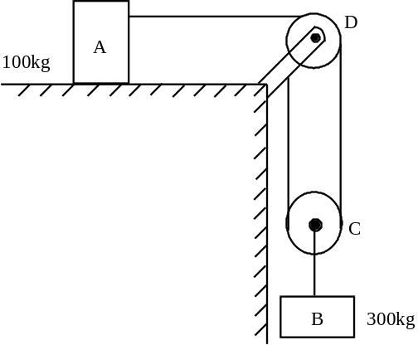 | 15
3. | - Discuss briefly about Newton’s Law of system of particles.  - A 9 Kg projectile is moving with a velocity of 30.5 m/sec when it explodes into two fragments. A and B weighing 2.3 Kg and 6.7 Kg respectively. Knowing that immediately after the explosion fragments A and B travel in directions defined respectively by 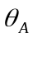= 45⁰ and 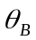 = 30⁰, Determine the velocity of each fragment.  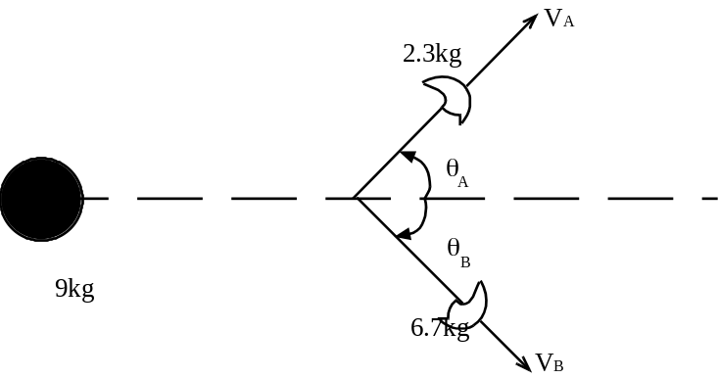 | 5  10
4. | A 40 Kg block is dropped from a height of 3m on the 20Kg pan of spring scale. Assuming the impact to be perfectly plastic, determine the maximum deflection of the pan. The constant of the spring is K = 20 KN/ m.  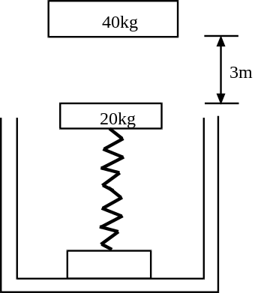 | 15
5. | Length of crane is 100mm and its connecting rod is 250mm as shown in fig if the crane is rotating in clockwise direction at 1500 rpm for the position as shown in fig. Determine the angular velocity of the connecting rod and velocity of position.  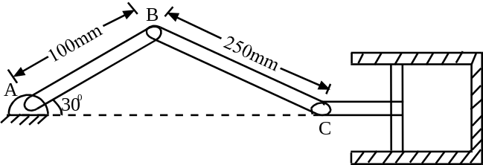 | 15
6. | - A pulley weighing 50 kg and having a radius of gyration of 0.4m is connected to two blocks as shown in fig. Assuming no axle friction determine the angular acceleration of the pulley and the acceleration of each block.  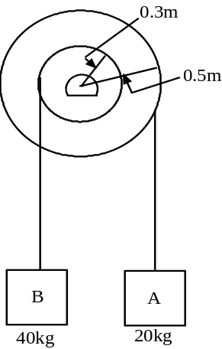  - A cylinder having the mass m and the radius are r is released from rest on an incline. Determine the velocity of body after it has rolled through a distance corresponding to a change in elevation h.  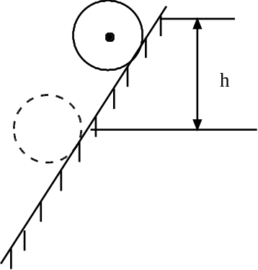 | 8  7
7. | Write short notes on (Any Two):  - Radial and transverse components of velocity and acceleration  - D’ Alemberts principle  - Impact | 2×5

